**APPENDIX:**

**Appendix A**- Additional Museum Information

The museum has recently created a new 34,000 square foot EcoDiscovery center which exactly doubles the museums size! Here children can:

• Watch the North American river otter

• Go on an Everglades Airboat Adventure

• Dig for fossils

• See an actual sized Saber tooth cat

• Walk under a Mammoth

• Learn more about Florida’s water system

• Learn methods on how to preserve the Everglades.

**Appendix B**- Game (Manatee Mania) Processing Code:

import ketai.sensors.*;

KetaiSensor sensor;

boolean pause = false;

float x, y, remoteX, remoteY;

float myAccelerometerX, myAccelerometerY;

int targetX, targetY, targetXX, targetYY;

int score;

int highscore;

float speedX, speedY = .01;

PImage manatee;

PImage plant;

PImage water;

PImage start;

PImage bottle;

PImage gameover;

PImage pausescreen;

PImage instructions;

PImage about;

int stage;

//below this comment (but not below setup), all for saving highscore after exit

String highscoreFile = "highscore.txt";

final String SC = "Score: ";

final String HS = "Highscore: ";

PrintWriter output;

BufferedReader reader;

void setup() {

stage = 1;

sensor = new KetaiSensor(this);

orientation(PORTRAIT);

textAlign(CENTER, CENTER);

textSize(36);

sensor.start();

strokeWeight(5);

imageMode(CENTER);

about = loadImage("about2013.png");

manatee = loadImage("8bitmanatee.png");

plant = loadImage("8bitplant.png");

bottle = loadImage("8bitbottle.png");

start = loadImage("pixelforestbackground2012.png");

gameover = loadImage("gameover2012.png");

pausescreen = loadImage("pausescreen.png");

instructions = loadImage("manateemaniainstructions.png");

init();

background(start);

//for highscore saving

importHighscore();

}

void draw() {

if (stage==1){ //start page

score = 0;//so score doesn't stay after you lose

if (mousePressed==true){

stage=4;

}

}

if (stage==2){

water = loadImage("watergif.gif");

background(water);

size(1200,1200);

// Targets

fill (0);

stroke(0, 60, 0);

tint(255, 255);

image(plant, targetX, targetY, 200, 200);

tint( 255, 255);

image(bottle, targetXX, targetYY, 50, 100);

stroke (60, 0, 0);

noStroke();

fill(250);

stroke(0);

rect(1, 1, 150, 100);

fill(0);

textSize(75);

text(score, 50, 50);

// manatee

speedX += (myAccelerometerX) * 0.2;

speedY += (myAccelerometerY) * 0.2;

if (x <= 25+speedX || x > width-25+speedX) {

speedX *= -0.8;

}

if (y <= 25-speedY || y > height-25-speedY) {

speedY *= -0.8;

}

x -= speedX;

y += speedY;

image(manatee, x, y);

// Collision

if (dist(x, y, targetX, targetY) < 100) {

score++;

init();

}

if (dist(x, y, targetXX, targetYY) < 100) {

stage=3;

init();

}

}

if (stage==4){

background(instructions);

noLoop();

delay(100);

loop();

if(mousePressed==true){

stage=2;

}

}

if (stage==3){ //gameover screen

background(gameover);

fill(20);

textSize(95);

text(score, 690, 625);

updateHighscore();

if (score > highscore){

highscore = score;

}else{

highscore = highscore;

}

text(highscore, 850, 520);

if (mousePressed==true){

stage=5;

noLoop(); //so it doesn't skip over stage 5

delay(100);

loop();

}

}

if (stage==5){ //about screen

background(about);

if (mousePressed==true){

setup();

}

}

}

void mousePressed() //pause on click, play on click

{if (stage==2){

if(pause == true){

noLoop();

tint(255, 255);

background(pausescreen);

}else{

loop();

}

if(pause == false){

pause = true;

}else{

pause = false;

}

}

}

void onAccelerometerEvent(float _x, float _y, float _z)

{

myAccelerometerX = _x;

myAccelerometerY = _y;

}

void init() { // items randomly respawn

x = int(random(25, width-25));

y = int(random(25, height-25));

targetX = int(random(25, width-35));

targetY = int(random(25, height-35));

targetXX = int(random(25, width-75));

targetYY = int(random(25, height-75));

}

//all the stuff below this is to save score after exit

void updateHighscore() {

if (highscore < score) {

highscore = score;

// Create a new file in the sketch directory

output = createWriter(highscoreFile);

output.println(highscore);

output.close(); // Writes the remaining data to the file & Finishes the file

}

}

void importHighscore() {

// Open the file from the createWriter()

reader = createReader(highscoreFile);

if (reader == null) {

highscore = 0;

return;

}

String line;

try {

line = reader.readLine();

} catch (IOException e) {

e.printStackTrace();

line = null;

}

if (line != null) {

highscore = int(line);

println(highscore);

}

try {

reader.close();

} catch (IOException e) {

e.printStackTrace();

}

}

**Appendix C**- Additional pictures from the museum

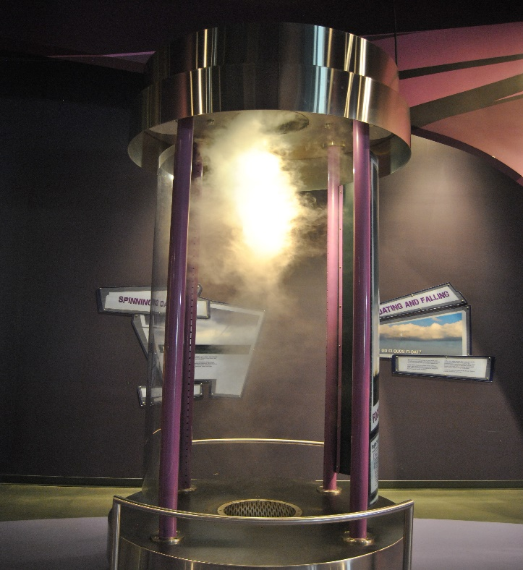

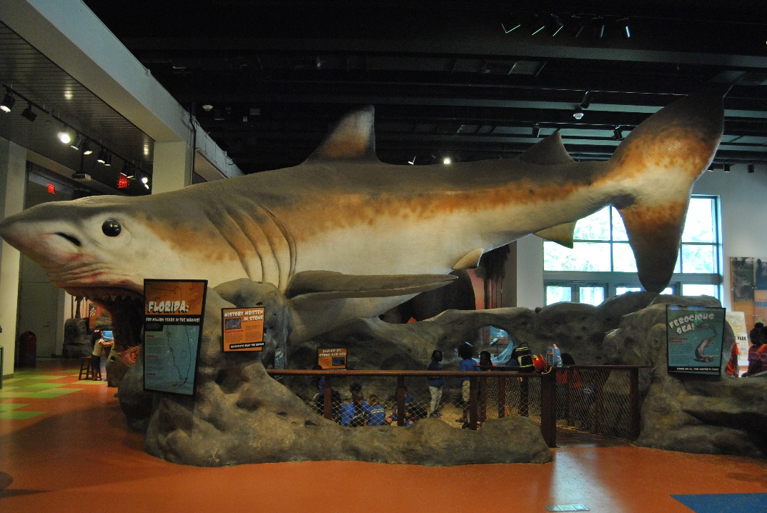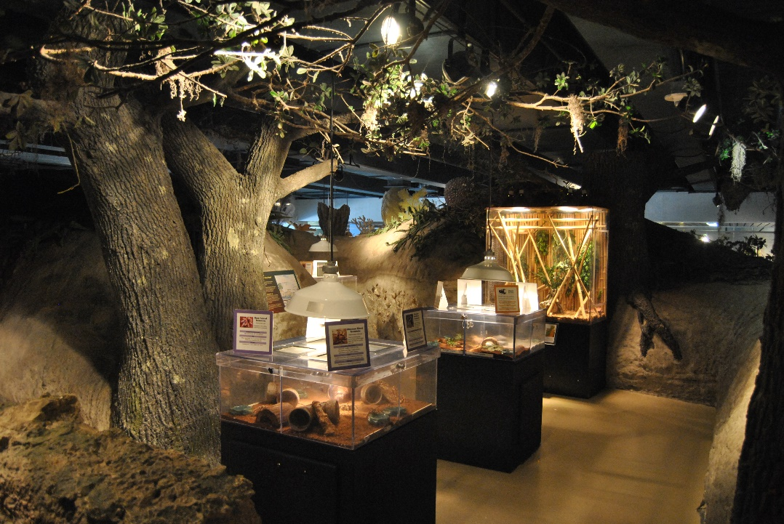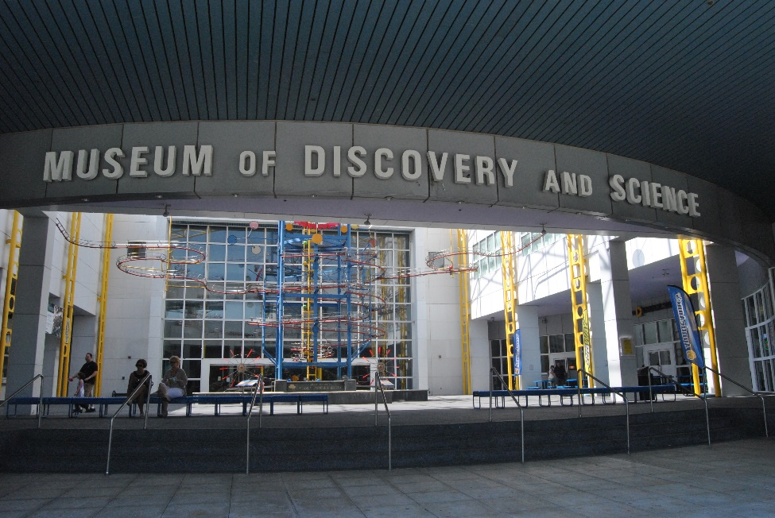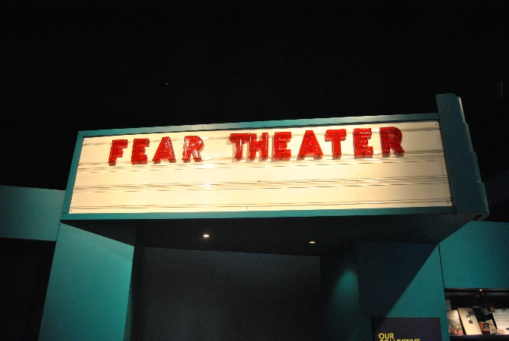

**Appendix D**- NFC TAGS

NFC tags are essentially, markers that when in contact with a receiver (found in the nexus) can activate a specific function. In this case it would have been used to teach more information to exhibit visitors as they passed by. Below is a sample code provided by “Blackboard” on how It would have worked.

